**CYBER SECURITY & ETHICAL HACKING**

**Assessment - 1**

**NAME:** M N Surya Teja Reddy

**REG.NO:** 20BCN7021

**CAMPUS:** VIT AP University

**TITLE:** Linux Command List Assessment

**Instructions: -**

The following assessment aims to test your understanding and practical knowledge of various Linux commands. Perform the tasks given below using the appropriate commands. Write down the command(s) used to complete each task. You can use any Linux distribution or command-line interface of your choice. Ensure that you provide the correct output or results for each task.

Note: It is recommended to perform this assessment on a Linux machine or virtual environment.

**File and Directory Operations:**

* ls: List files and directories

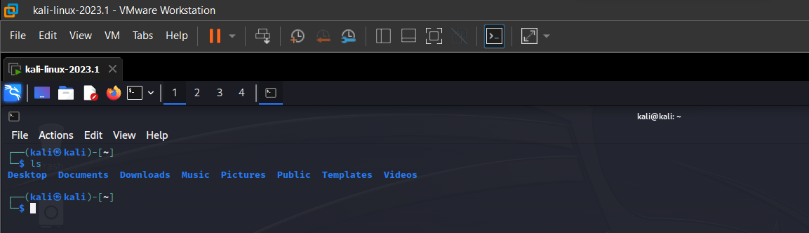

* cd: Change directory

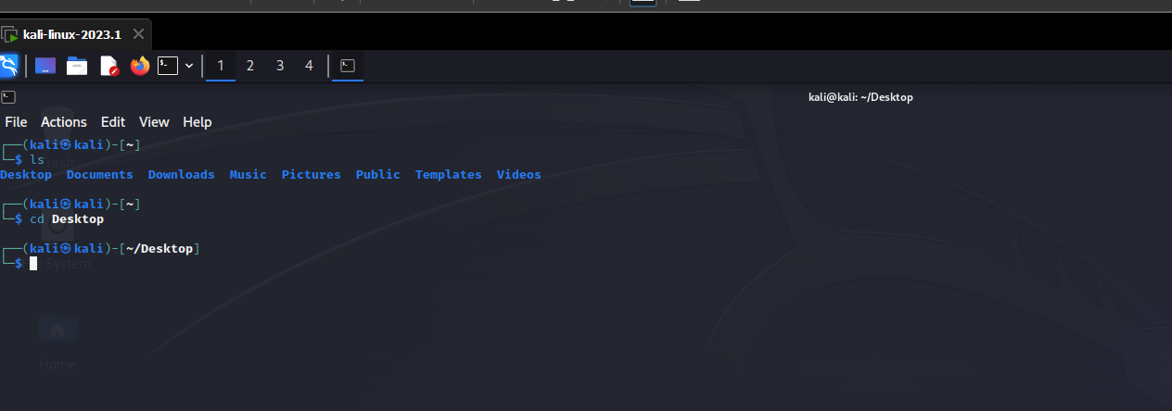

* pwd: Print working directory

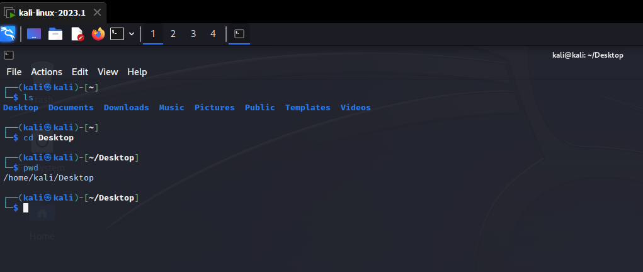

* mkdir: Make directory

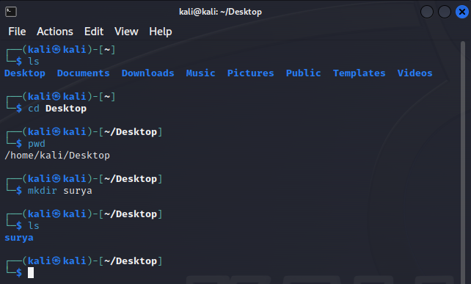

* touch: Create an empty file



* cp: Copy files and directories

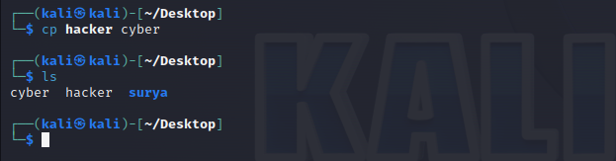

* mv: Move or rename files and directories

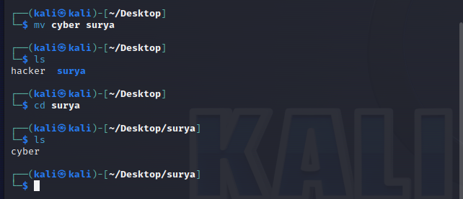

* rm: Remove files and directories

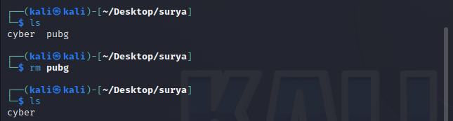

* find: Search for files and directories

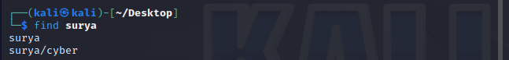

**File Viewing and Editing:**

* cat: Concatenate and display file content

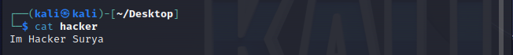

* less: View file content with pagination

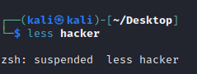 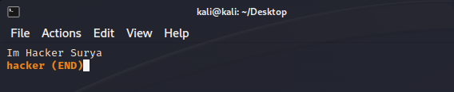

* head: Display the beginning of a file



* tail: Display the end of a file



* nano: Text editor for creating and editing files

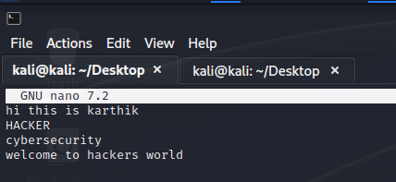

* vi/vim: Powerful text editor for experienced users

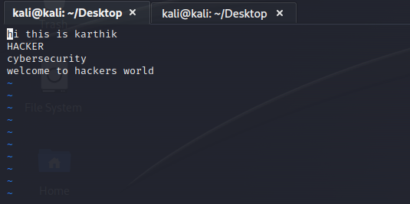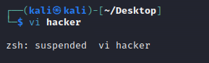

**File Permissions:**

* chmod: Change file permissions

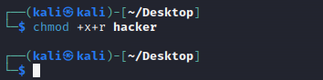

* chown: Change file owner

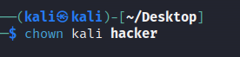

* chgrp: Change file group

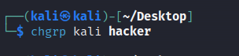

**File Compression and Archiving:**

* tar: Archive files

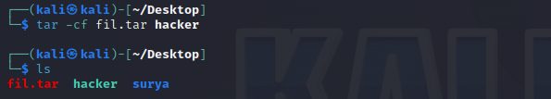

* gzip: Compress files

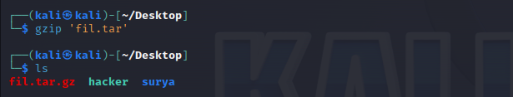

* unzip: Extract files from a ZIP archive

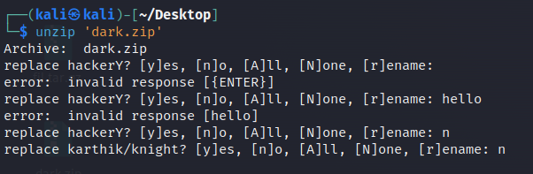

**Process Management:**

* ps: List running processes

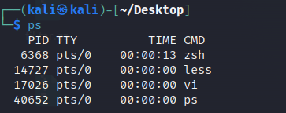

* top: Display real-time system information and processes

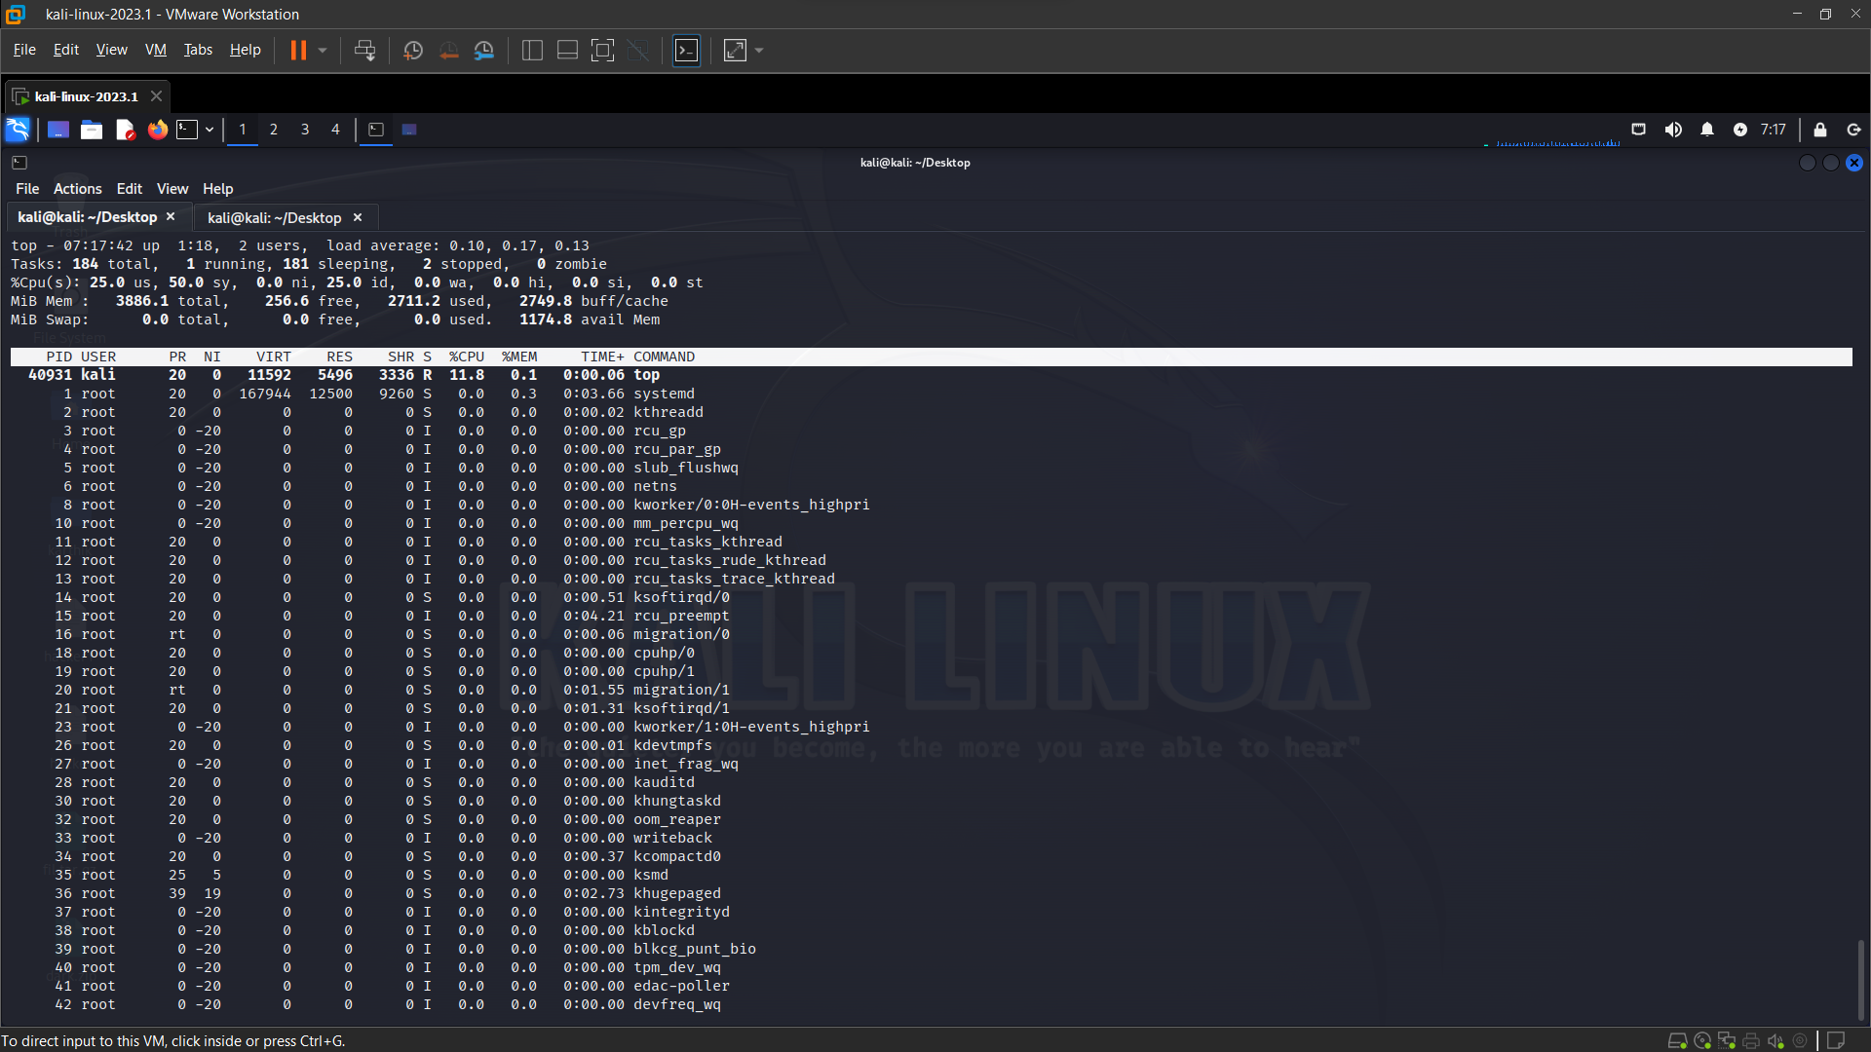

* kill: Terminate processes

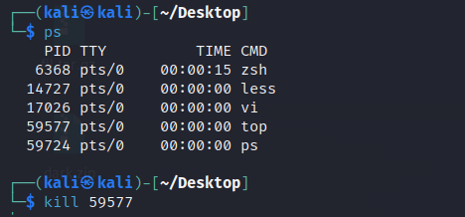

* bg: Run processes in the background

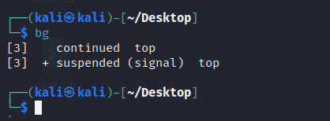

* fg: Bring background processes to the foreground



**System Information:**

* uname: Print system information

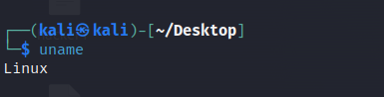

* df: Display disk space usage

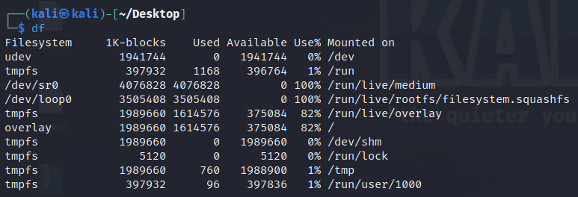

* free: Display memory usage

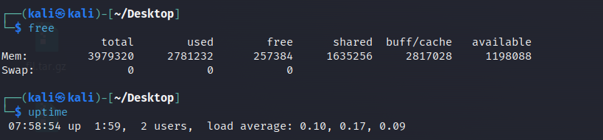

* uptime: Show system uptime



* who: Display logged-in users

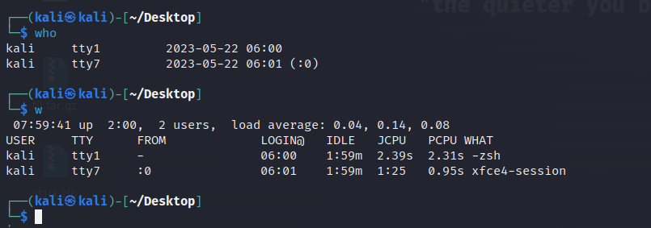

* w: Display logged-in users and their activities



**Networking:**

* ifconfig: Configure network interfaces

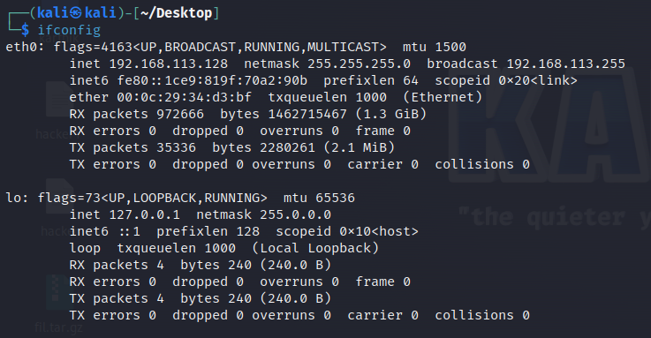

* ping: Send ICMP echo requests to a network host

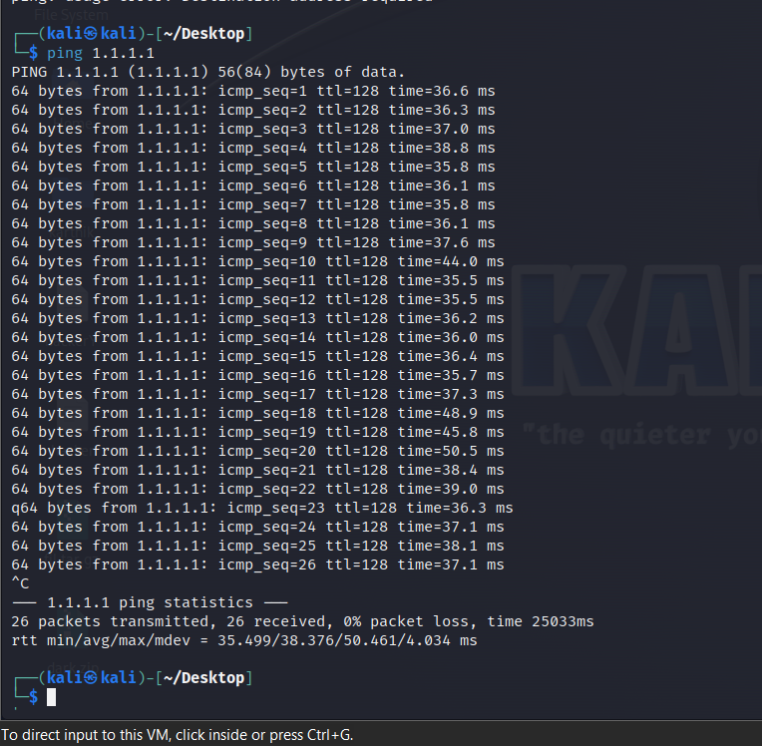

* ssh: Securely connect to a remote system

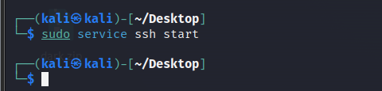

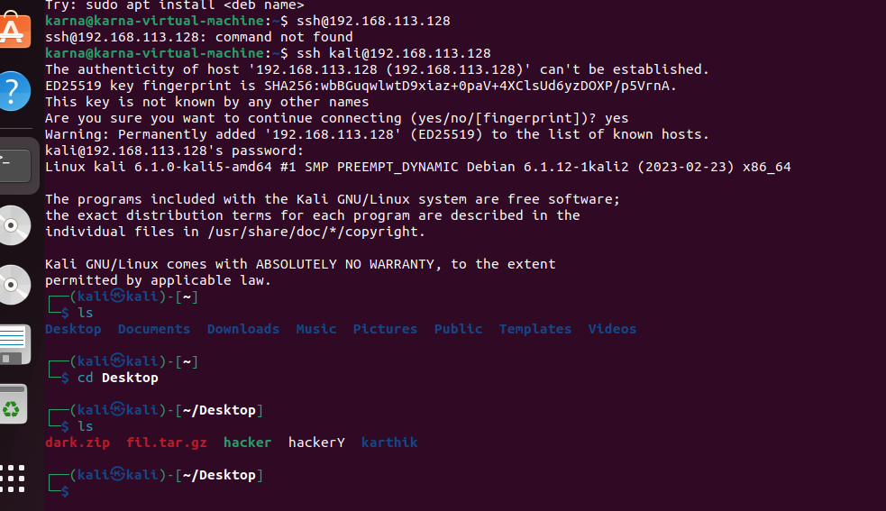

* scp: Securely copy files between systems

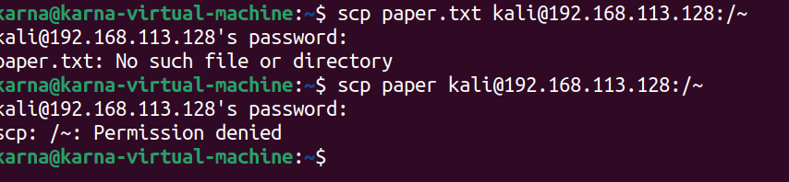

* wget: Download files from the web

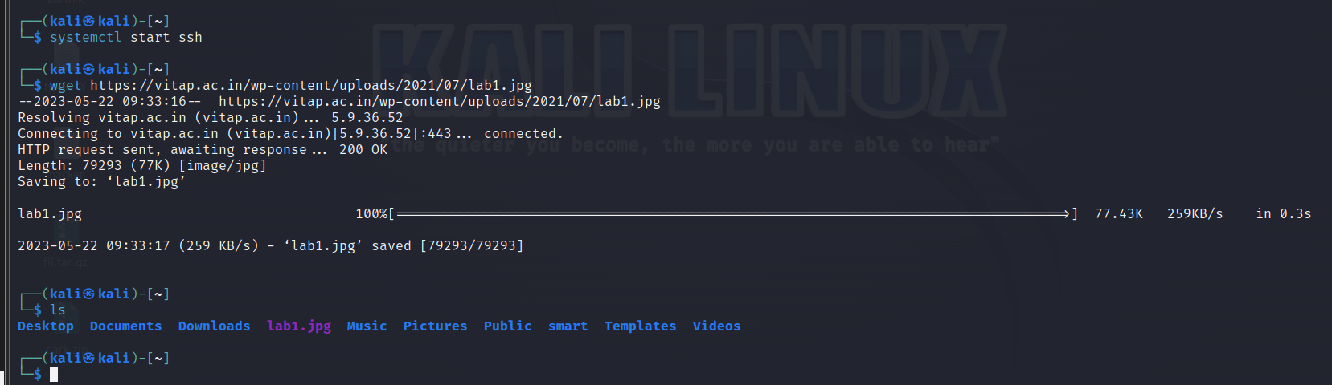

**System Administration:**

* sudo: Execute commands with superuser privileges

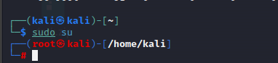

* apt-get: Package management for Debian-based distributions

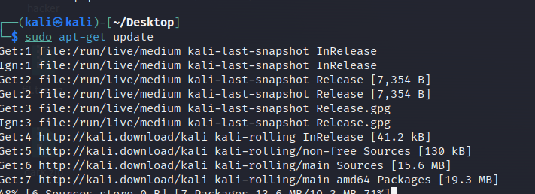

* systemctl: Manage system services

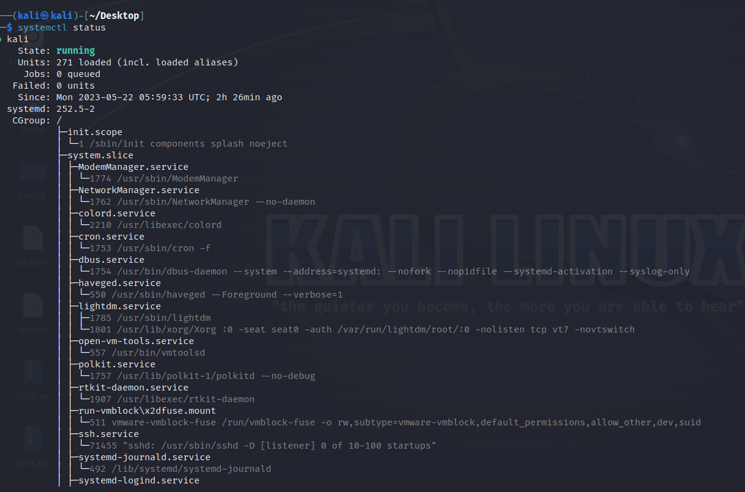]

* crontab: Schedule recurring tasks

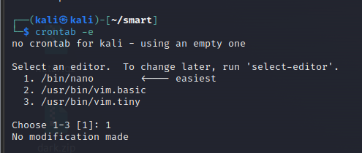

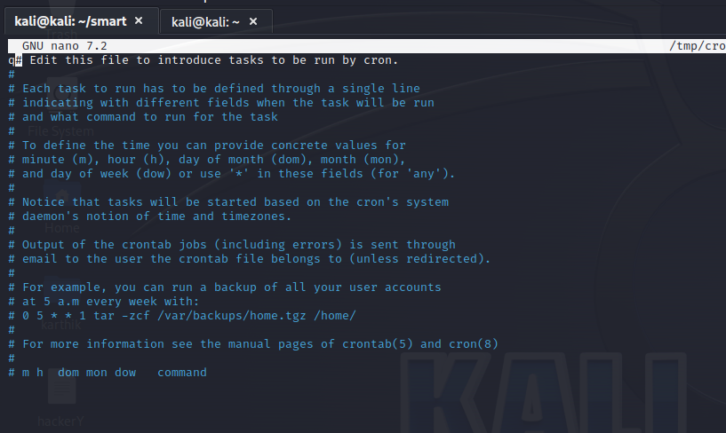

* useradd: Add a new user

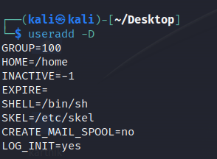

* passwd: Change user password

